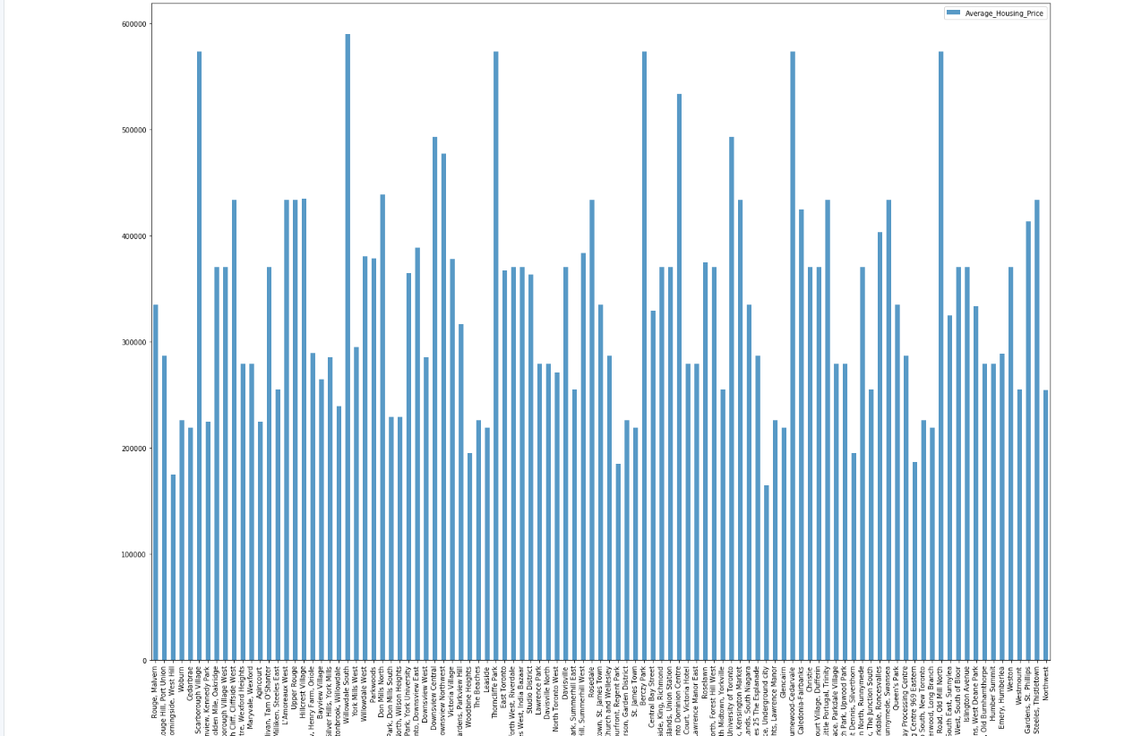

1. Introduction:

Coronavirus has affected people immensely, while half of the population is working from home another is finding it difficult to hold on to jobs.The population working from home has spent last year in lockdown or taking precautions, this has caused them to save considerable amount of money giving them the ability to save for their first home. While there are other people who are tired of conditions in their area and looking to shift to a new place. This project will help them with their choice. The purpose of this Project is to help people in exploring better facilities around their neighborhood. It will help people make smart and efficient decisions.

Coronavirus and lockdown have caused lots of people to migrate to various states of Canada and needed lots of research for good services available in these neighbourhoods. This project is for those people who are looking for better neighborhoods. For ease of accessing to Cafe, School, Super market, medical shops, grocery shops, mall, theatre, hospital, like minded people, etc

This Capstone Project aims to create an analysis of features for people migrating to Toronto to search for a best neighborhood as a comparative analysis between neighborhoods. The features include median housing price and better school according to ratings, crime rates of that particular area, road connectivity, weather conditions, good management for emergency, water resources.

It will help people to get awareness of the area and neighborhood before moving to a new city, state, country or place for their work or to start a new fresh life.

This Project aim to create an analysis of features for people migrating to Toronto to search a best neighborhood which might meet the needs of the clients. The features include housing price and better school according to their ratings, crime rates of the area, roads, weather conditions, emergency services, water resource management.

It will help people to get awareness of the area and neighborhood before moving to a new city, state, country or place for their work or to start a new fresh life. This project will also help immigrants which are expected to tp 400,000 by 2023.

2. Data Section

Data Link: https://en.wikipedia.org/wiki/List_of_postal_codes_of_Canada:_M

Will use Toronto dataset which we scrapped from wikipedia on Week 3. Dataset consisting of latitude and longitude, zip codes.

Foursquare API Data:

We will need data about different venues in different neighborhoods of that specific borough.  
In order to gain that information we will use “Foursquare” locational information. Foursquare is a location data provider with information about all manner of venues and events within an area of interest. Such information includes venue names, locations, menus and even photos. As such, the foursquare location platform will be used as the sole data source since all the stated required information can be obtained through the API.

After finding the list of neighborhoods, we then connect to the Foursquare API to gather information about venues inside each and every neighborhood. For each neighborhood, we have chosen the radius to be 100 meter.

The data retrieved from Foursquare contained information of venues within a specified distance of the longitude and latitude of the postcodes. The information obtained per venue as follows:

1. Neighborhood

2. Neighborhood Latitude

3. Neighborhood Longitude

4. Venue

5. Name of the venue e.g. the name of a store or restaurant

6. Venue Latitude

7. Venue Longitude

8. Venue Category

**Map of Toronto**

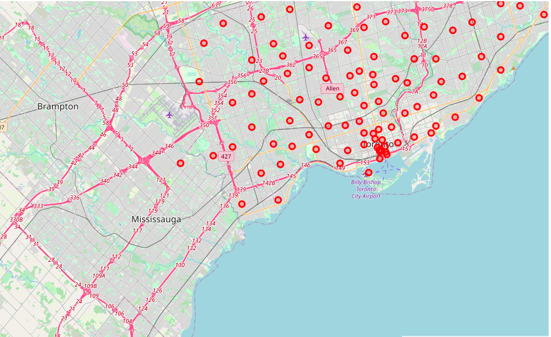

3. Methodology Section

Clustering Approach:

To compare the similarities of two cities, we decided to explore neighborhoods, segment them, and group them into clusters to find similar neighborhoods in a big city like New York and Toronto. To be able to do that, we need to cluster data which is a form of unsupervised machine learning: k-means clustering algorithm.

**Using K-Means Clustering Approach** | Most Common Venue

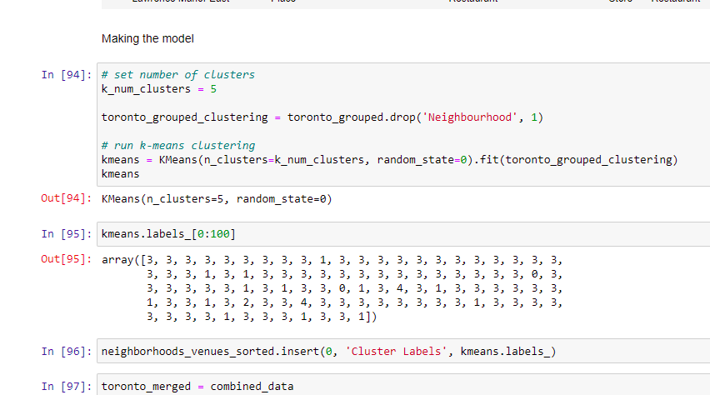

**Most Common Venues near Neighborhood** | Using Clustering

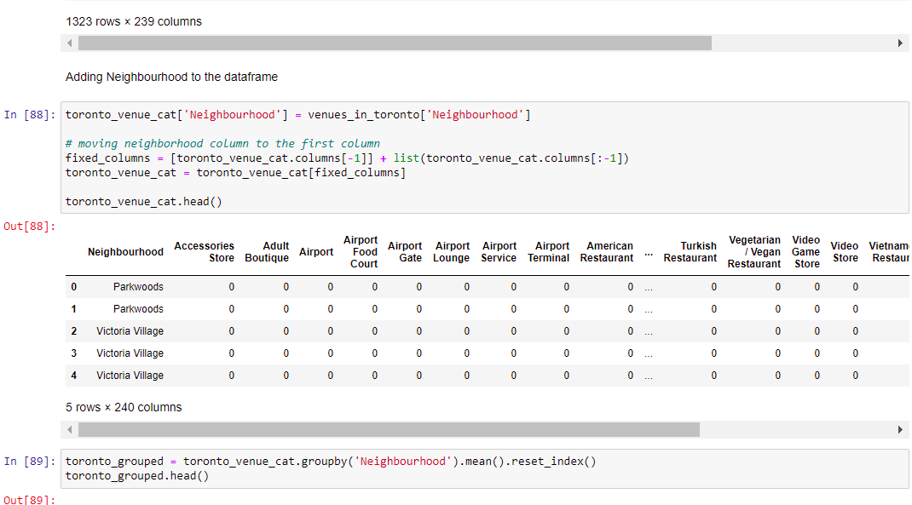

Work Flow:

Using credentials of Foursquare API features of near-by places of the neighborhoods would be mined. Due to http request limitations the number of places per neighborhood parameter would reasonably be set to 100 and the radius parameter would be set to 500.

would be set to 500.

4. Results Section

**Map of Clusters in Toronto**

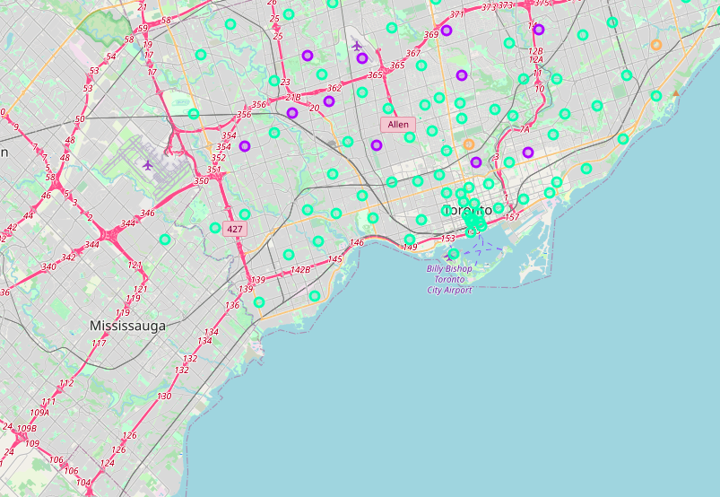

The Location:

Toronto is a popular destination for new immigrants in Canada to reside. As a result, it is one of the most diverse and multicultural cities in Canada, being home to various religious groups and places of worship.

Foursquare API:

This Capstone project have used Four-square API as its prime data gathering source as it has a database of millions of places, especially their places API which provides the ability to perform location search, location sharing and details about a business.

5. Discussion Section

Problem Which Tried to Solve:

The major purpose of this project, is to suggest a better neighborhood in a new city for the person who are shifting there. Social presence in society in terms of like minded people. Connectivity to the airport, bus stand, city center, markets and other daily needs things nearby.

6. Conclusion Section

In this Capstone project, using k-means cluster algorithm I separated the neighborhood into Five different clusters and for 1323 different locations from dataset, which have very-similar neighborhoods around them. Using the charts above results presented to a particular neighborhood based on the different culture and ease in quality of life.

I will really satisfied by the results of this project and they clearly explain to me how far have I come.  
This project has shown me a practical application to resolve a real situation that has impacting personal and financial impact using Data Science tools.  
The mapping with Folium is a very powerful technique to consolidate information and make the analysis and decision better with confidence.

Future Works:

This Capstone project can be continued for making it more precise in terms to find best house in Toronto. Best means on the basis of all required things(daily needs or things we need to live a better life) around and also in terms of cost effective.